

Lake Dallas Public Library
Exam Proctoring Policy

Index

Introduction …………………………………………………………………………………...pg. 3
Guidelines …………………………………………………………………………………….pg. 4
Proctoring Requests …………………………………………………………………………..pg. 4
Proctoring Request Form ……………………………………………………………………..pg. 5
Student Responsibilities ………………………………………………………………………pg. 6
Library Responsibilities ………………………………………………………………………pg. 6

Introduction
The Lake Dallas Public Library, in order to provide necessary services to the community, provides proctoring services for written and online exams at no charge. Individuals seeking proctoring services can register for a day and time at the library or submit a Proctoring Request Form online by emailing it to LakeDallasStaff@lakedallas.com.

Guidelines
- The Lake Dallas Public Library provides exam proctoring services at no charge.
- Proctoring services are available based on the availability of the Library Director or other staff with an MLS/MLIS degree.
- The Lake Dallas Public Library can proctor written and online exams.
- Direct supervision will not be provided.
- The library reserves the right to refuse to proctor any exam.
- Library staff cannot interpret exam instructions for test-takers or provide technical assistance that directly relates to the exam.
- Library staff will not sign any statement required by the test administrators or administrating institution that is inconsistent with the library’s policies or with how the exam was administered.
- Proctoring appointments must be scheduled at least 2 business days in advance of the desired exam start time and date.
- Exams must be completed 15 minutes before the library’s scheduled closing time unless otherwise cleared by the Library Director.
- If materials need to be mailed to the test-taker’s school or test administering institution, the test-taker is responsible for providing an addressed envelope with postage.
- Library staff are not responsible for completed exams once they leave the library’s possession.

Proctoring Requests
Proctoring requests can be made in the library or emailed to LakeDallasStaff@lakedallas.com. Proctoring requests must include a completed Proctoring Request Form and must be delivered to library staff at least two business days before the exam.

Proctoring requests are not guaranteed and are contingent upon staff availability.

Proctoring Request Form
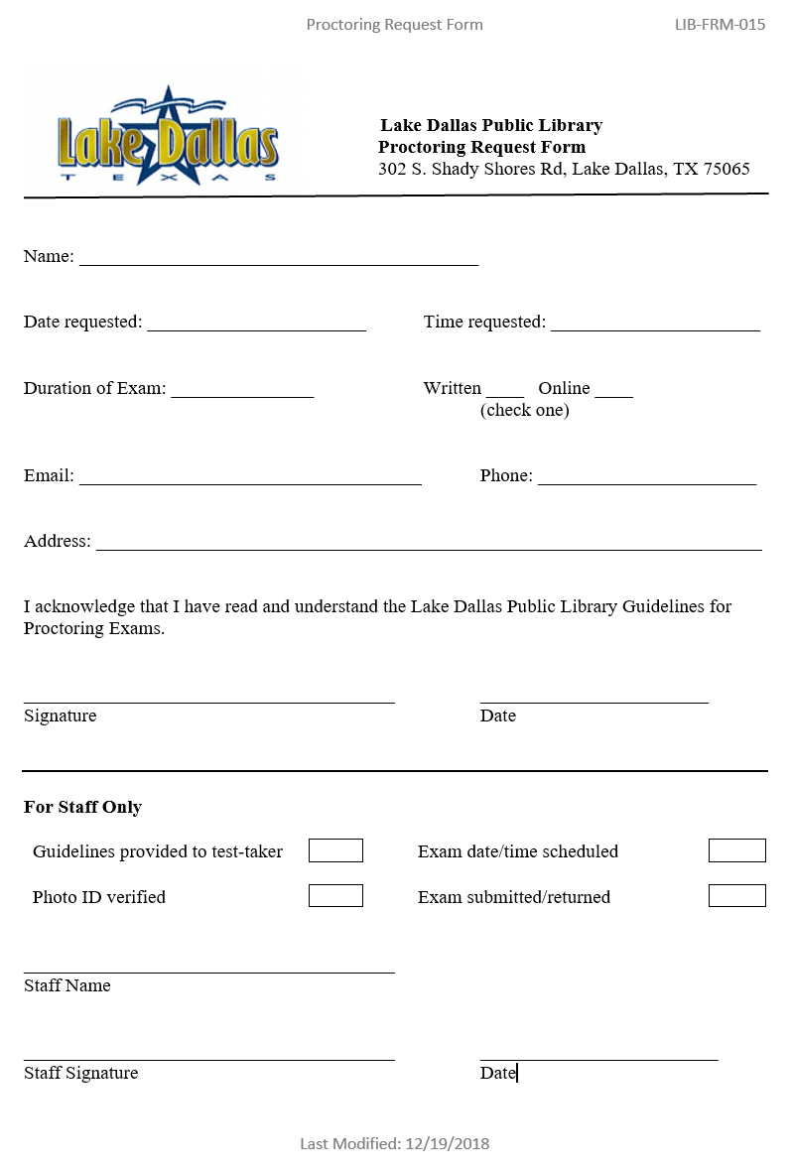
Student Responsibilities
- Complete the Proctoring Request Form and return it at least two business days before the date needed for the exam.
- Check with staff to ensure that the Proctoring Request Form was received, and that staff are available to proctor the exam.
- Read the Guidelines for exam proctoring and ensure that they meet your institution’s approval.
- Coordinate transfer of the exam from the institution to the library and verify that the library received the exam. Library staff will not contact test takers about exams.
- Arrive at the scheduled time and date for your exam.
- Bring your own supplies for the exam. If a computer is necessary for the exam, show up for your exam at least 30 minutes early to ensure a computer is available for your used.
- Notify the library immediately if you cannot make it to your schedule appointment for proctoring.
- Present a valid photo ID (including state issued, military, or academic ID) when you arrive to take your exam.
- If the institution does not provide a self-addressed stamped envelope for returning an exam by postal mail, the student must provide it.

Library Responsibilities
- Library staff must confer with the Library Director or other MLS/MLIS staff before scheduling an exam.
- If the library must cancel an exam for any reason, staff must notify test-takers in a timely manner.
- Staff must ensure that test-takers complete exams as required before submitting any paperwork that affirms the validity of the test or absence of deceptive practices in completing the exam.

